Uniting Reformed Church Website content

## Home

* 1. The Church
  2. Schedule

## About Us

* 1. History

In the second century the church already was divided into two, namely the Eastern and Western Church. Since these times there has always been people in the church who have been unhappy about certain developments within the church.

Our church, backdating in history it originates from a movement called "Protestant". Protestant because great scholars protested again the only then church "Roman empire" system and practices.

Many voices from different countries raised against the developments in the Church. However noticeable that impacted the birth of our church were: **Martin Luther**, who studied to become a priest in the church. He was opposed to the system of indulgence, and he wrestled with the question "How cab a person be certain of the grace of God?". One day he nailed his points of view known as the 95 doctrines to the door of the Church in Wittenberg. As a result he had to appear before the pope, but he stuck to his point of view. Martin Luther assisted in the publication of a Greek translation of the Bible. I. Addition, he wrote many books to explain the meaning of the Bible and made it understandable for normal people. The Lutheran Church developed from Luther's standpoint on the Bible and the church.

The other great voice raised from Switzerland and France was **John Calvin**, he protested in Switzerland and France against the situation within the church. He further wrote a book called "The Institution" in which he indicated how the church should be Reformed and managed through Christian education, that is based on the Bible. Furthermore, he made suggestions on how the church could be made more "democratic". He denounced the power of the papal system. He wanted lay people to participate more in the activities and life of the Church. He encouraged them to read the Bible themselves, and act and live accordingly, and not just accept the guidance of the "clergy".

The Reformed Church system is based on John Calvin's suggestions. This is also the system that our Church follows.

With time as more and more raised, such as **Zwingli** and **Beza**, this led to a split in the Roman Catholic Church and the establishment of different Protestant churches in Europe.

In the 1490s the missionaries started to come to Africa, whilst in the 1737s the Christian missionaries bringing in the Protestant churches such as Lutheran Church, Reform Church amidst other arrived in South Africa. Our Church "Uniting Reformed in Southern Africa" ordinates from South Africa, as initially that were most missionaries settled. In the 1970s our church first established in the coloured communities and later in the black communities in Kaokoland. Back then our church was known by its Afrikaans name (EGKA-Evangelie Reformeerde Kerk in Africa), which in English translates to Evangelical Reformed Church in Africa. After Namibia's independence, leaders of the Church set and agreed to denounce the above apartheid era name and we became what we know today in the whole of Africa  **in Southern Africa**, and in the Afrikaans language **Verenigende Gereformeerde Kerk in Suider** **Afrika**.

* 1. Leadership

**The Church's Hierarchy structure**

Highest to the lowest structure;

A) One General Synod Commission (S.A)

B) Seven Regional Synod Commissions, 6 in S.A, one in Namibia, which known as Namibia Regional Synod.

C) Presbyteries Commissions, which S.A its own various Presbyteris, whilst in Namibia we have 5, namely Windhoek, Ngweze, Takwasa, Mariental and Oruman.

D) Congregation; we close to 24 Congregations in Namibia, under various Presbyteries. Whilst the Windhoek Presbytery has a total of 7 Congregations.

Note: depending on the capabilities of different Congregations, they are allowed to establish Wards, which later on if they grow and able to sustain itself, it can become an independent Congregation.

E) Church Council; every Congregation is led by a governing body known as Church Council, consisting of a Reverend (chairperson of the Congregation), a vice chairperson, Elders and Deacons.

F) Finally, we have the Church members, who are the reasons for the existence and functioning of the Church. The Church serves its members with ecclesiastical services and the community at large when the need arise.

* 1. **Church Order**; as Church we function with a Church Order. This piece of document or a book every Regional Synod has, with laws and regulations, composed with guidance and connotations from the Bible in order to run the church in an orderly manner as per the teachings and commands of the Bible.

Note: in the same book (church order), leaders of the Church discussed and agreed that the church should have the following official bodies (Ministries) as part and parcel of the Church/Congregation, following the very same Hierarchy structure of the entire Church (URCSA).

A) CMM-Christian Men Ministry.

B) CWM- Christian Women Ministry.

C) CYM- Christian Youth Ministry.

D) Sunday School Ministry.

* 1. Gallery

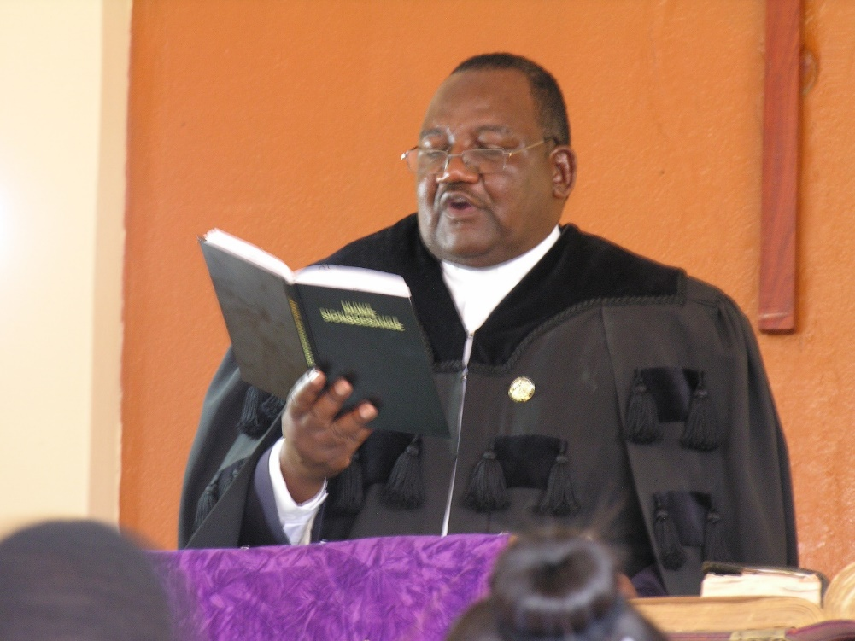

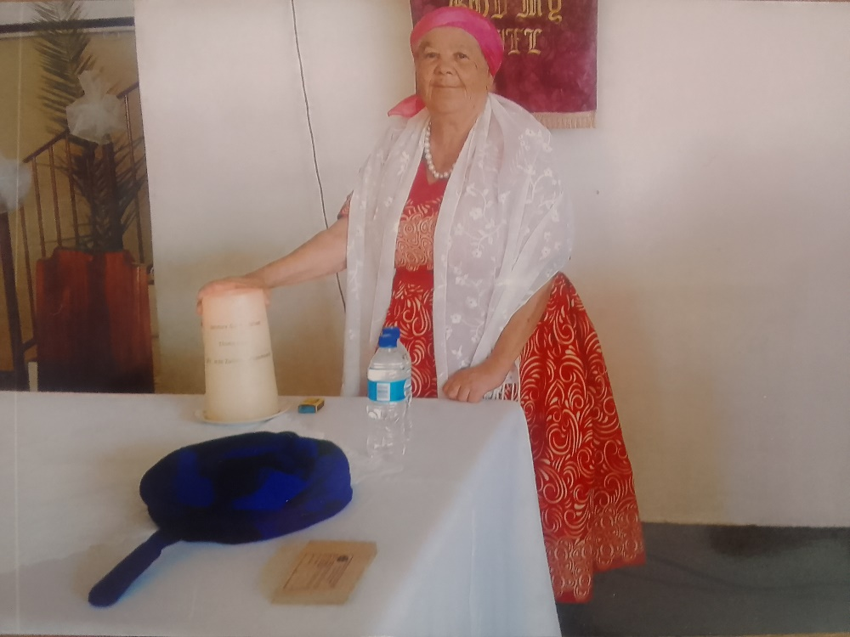

## Services

* 1. Sermons
  2. Applications
     1. Confirmation Classes
     2. Baptism
     3. Marriage
     4. Repentance

## Ministries

* 1. Sunday School
  2. Christian Youth Ministries
     1. Senior CYM

**Motto**

**Let CYM live and not die**

**Mission statement**

To act as an ambassador for the URCSA Katutura in spreading the word of God in singing and preaching

**General attitude**

Members should show pride and loyalty towards the CYM and committee. All are expected to be diligent, disciplined and respectful towards each other at all times.

**Bible reference verse**: Philippians 4:13 “I can do all things through Christ who strengthens me”

**Committee Members**

|  |  |
| --- | --- |
| **Position** | **Member (s)** |
| Chairperson | Richard |
| Vice-chair | Manuel |
| Secretary | Lusia |
| Vice Secretary | Ondina |
| Treasurer | Annabella |
| Vice Treasurer | Amelia |
| Additional members | Melquisedek |
| Cynthia |

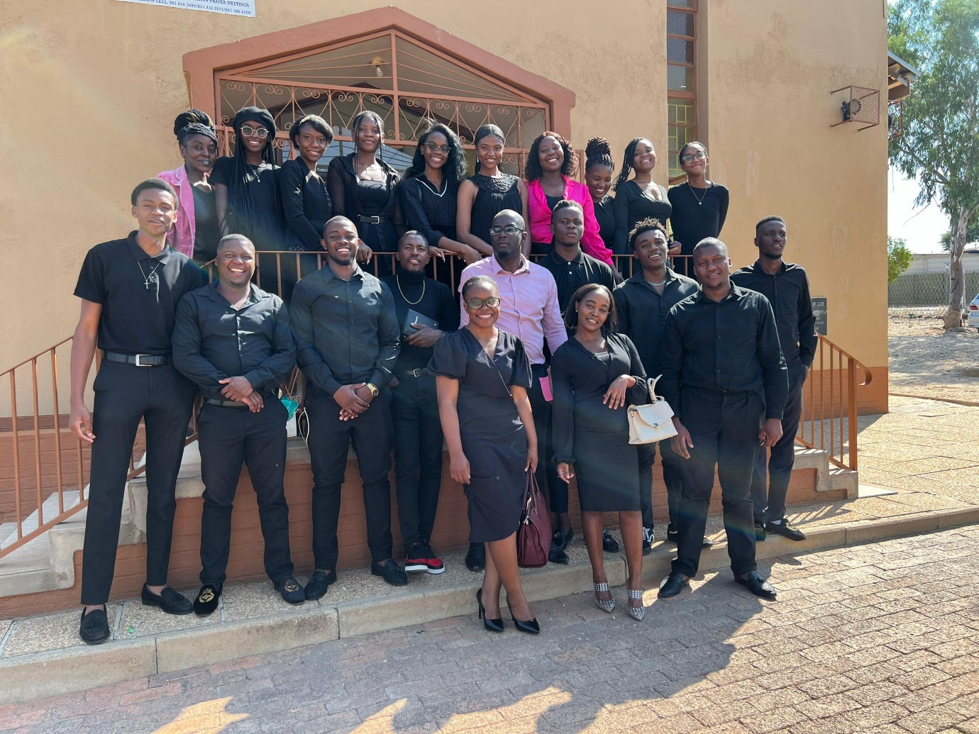

* + 1. Junior CYM
  1. Christian Women Ministries

**Motto**

Women in service of Christ and His Church

**Values**

The CWM of the URCSA is founded upon the following values:

* Faith in the Divine God (Father, Son and the Holy Spirit)
* Patience and dedication to the service of God.
* Humility and humbleness, in serving God and one another
* Love, goodness and care towards others
* Trustfulness, trustworthiness towards one another
* Respect for oneself and one another

**Vision**

To be a Christian Women’s Ministry that strives to be dynamic in unity, reconciliation, justice and obedience.

**Mission**

Worship, build the faith and the spirituality of the women so that they can be faithful witnesses for the Christ in the church and in the society, oppose that which is in conflict with the Christian faith both within and outside the church of Christ.

Work in partnership with the other ministries within and with the church in its ecumenical relations in building a community of believers where the walls of gender, race language and culture are demolished and equality acknowledged.

## News

* 1. Newsletter

**Christian Youth Ministry wins choir competition**

2024-08-05 BY PRICILLA MUKOKOBI

Conductor Manuel Sasindere led his choir from the Christian Youth Ministry to victory at the Shabbach Clash Choir Competition on Saturday, and earned a cash prize of N$1500 and a floating trophy.

Read more: Christian Youth Ministry wins choir competition - New Era <https://neweralive.na/christian-youth-ministry-wins-choir-competition>

* 1. Upcoming Activates

**Raffle Contest**

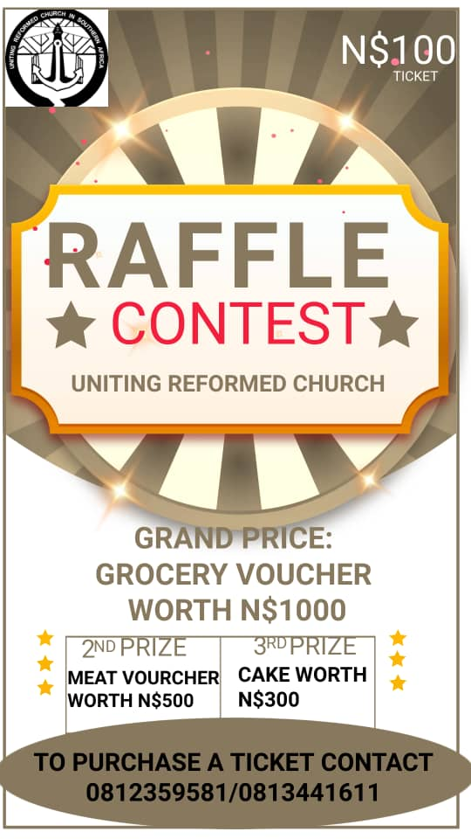

## Contact

* 1. Contributions